WEB APPLICATION PENETRATION TESTING

Access Control Assessment Report
User ID Controlled by Request Parameter with Password Disclosure
Platform: PortSwigger Web Security Academy | Tools: Browser Developer Tools

1. Executive Summary
The lab demonstrated an access-control weakness that allowed a regular user to access the administrator's account page by manipulating a user identifier. The administrator's password was also exposed in the HTML response as the value of a password input field. The password was therefore available in the page source/DOM despite being visually masked. The disclosed credential was used to access the administrator account, and the lab was completed by deleting the wiener user.

2. Objective and Scope
Objective: test whether a user can access another account by changing a request identifier and determine whether sensitive credential data is exposed in the returned page.
Scope: the intentionally vulnerable PortSwigger Web Security Academy lab environment. Findings and impact are limited to the supplied lab evidence.

3. Methodology
- Logged in to the lab as the regular user wiener.
- Changed the user identifier in the account request to access the administrator account page.
- Inspected the administrator account page using browser developer tools.
- Identified the password input element and observed that its value attribute contained the password.
- Used the disclosed credential to authenticate as administrator.
- Accessed the admin panel, deleted the wiener account, and confirmed that the lab was solved.

4. Findings

4.1 Broken Access Control / IDOR
The application did not adequately verify whether the authenticated user was authorised to access the account identified by the request parameter. This allowed horizontal privilege escalation to the administrator's account page.

4.2 Sensitive Password Disclosure
The administrator password was included in the HTML as the value of an input element with type="password". Visual masking did not protect the underlying value from a user able to inspect the page source or DOM. This exposed a credential that could be used to authenticate as the administrator.

5. Evidence
Evidence is arranged in chronological order. The administrator password has been redacted from the developer-tools screenshot. Do not publish the unredacted original.
Figure 1 — Regular user account
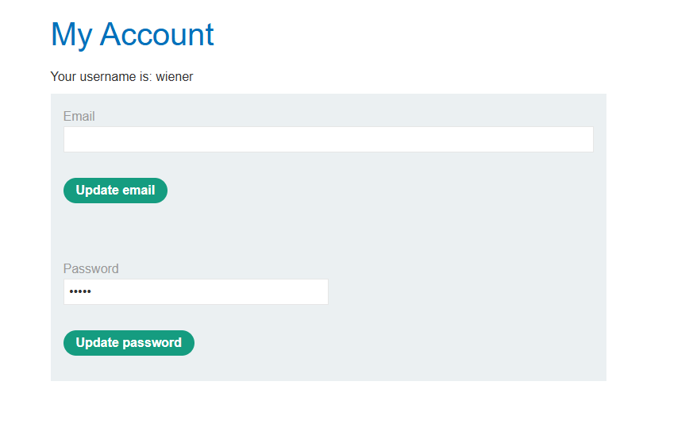
The application is accessed using the regular wiener account.
Figure 2 — Password exposed in the HTML
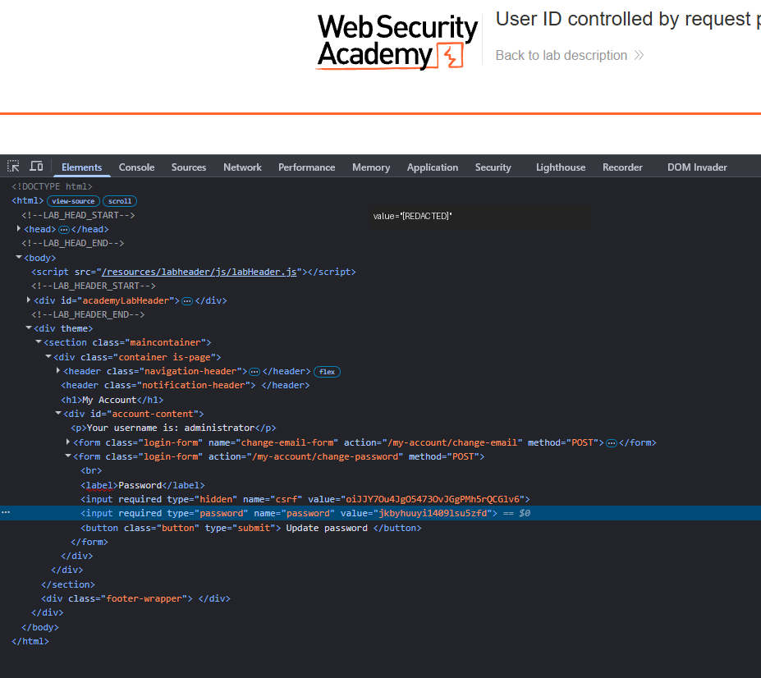
Developer Tools shows a password input with a value attribute.

Figure 3 — Access to admin panel
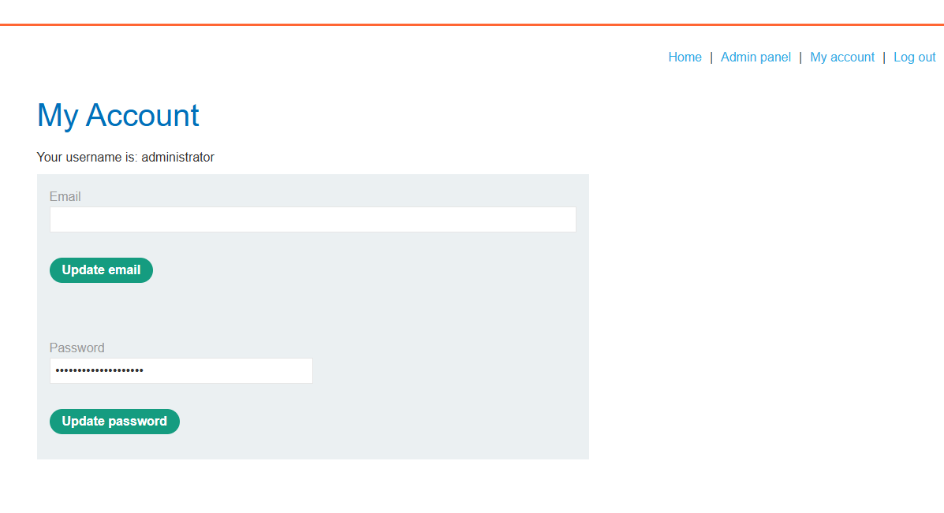
The manipulated account request displays the administrator account page.
Figure 4 — Administrative action and lab completion
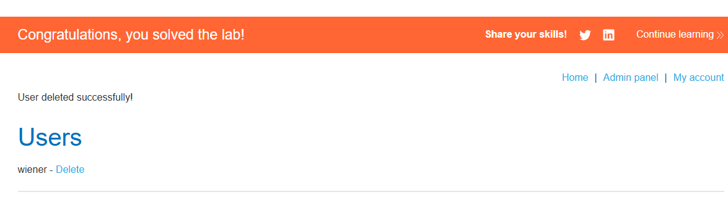
The admin panel confirms the deletion action and PortSwigger displays the lab success message.

6. Impact
The demonstrated chain allowed a regular user to obtain an administrator credential and gain administrative access. Depending on the application's administrative capabilities, this could result in unauthorised disclosure or modification of data and account-management actions. The lab evidence confirms an administrative deletion action; it does not establish impact on any real-world system.

7. Severity
CVSS v3.1: 8.3 — High (indicative)
Vector: CVSS:3.1/AV:N/AC:L/PR:L/UI:N/S:U/C:H/I:H/A:L
This indicative score assesses the demonstrated attack chain, assuming remote access, an authenticated low-privilege starting account, and high confidentiality and integrity impact with low availability impact. It is not a score assigned by PortSwigger. In a production assessment, score each finding separately and adjust the vector to the actual environment and business impact.

8. Recommendations
- Enforce server-side object-level authorization checks on every request involving user accounts.
- Never include plaintext passwords or reusable credentials in HTML responses, hidden fields, or client-side code.
- Do not rely on password input masking as a security control; masking changes only visual presentation.
- Require secure authentication and authorization checks for administrative functions.
- If credentials may have been exposed, reset the affected password and invalidate active sessions.
- Review application responses and logs for accidental disclosure of secrets.

9. Conclusion
The lab combined an access-control weakness with sensitive password disclosure. Changing the account identifier exposed the administrator page, and inspecting the HTML revealed the administrator password in the password field's value attribute. Strong server-side authorization and strict prevention of credential exposure are necessary to prevent this type of account compromise.

Reference
PortSwigger Web Security Academy — Access control:
https://portswigger.net/web-security/access-control

Disclaimer
Testing was performed in an intentionally vulnerable PortSwigger Web Security Academy training environment. Only test systems for which explicit authorization has been obtained.

